**Assignment No:-17**

Name:-Suryawanshi Sangramsingh Sambhaji

Batch: - Delta - DCA (Java) 2024 Date:-27/5/2024

**1. Given an array and a value, find if there is a triplet in array whose sum is equal to the given value.**

**If there is such a triplet present in array, then print the triplet and return true. Else return false.** Examples:

Input: array = {12, 3, 4, 1, 6, 9}, sum = 24;

Output: 12, 3, 9

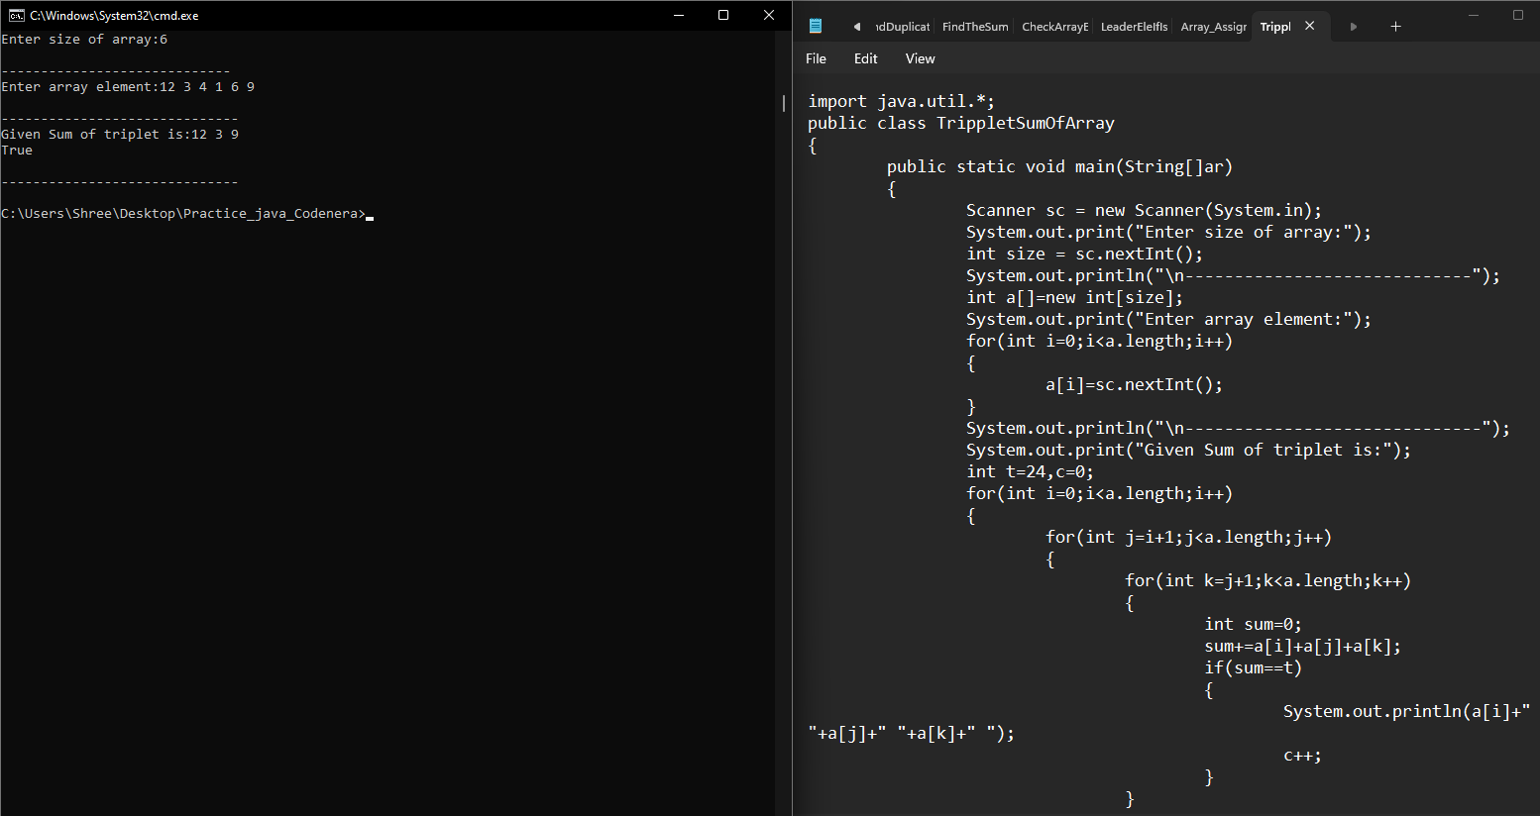

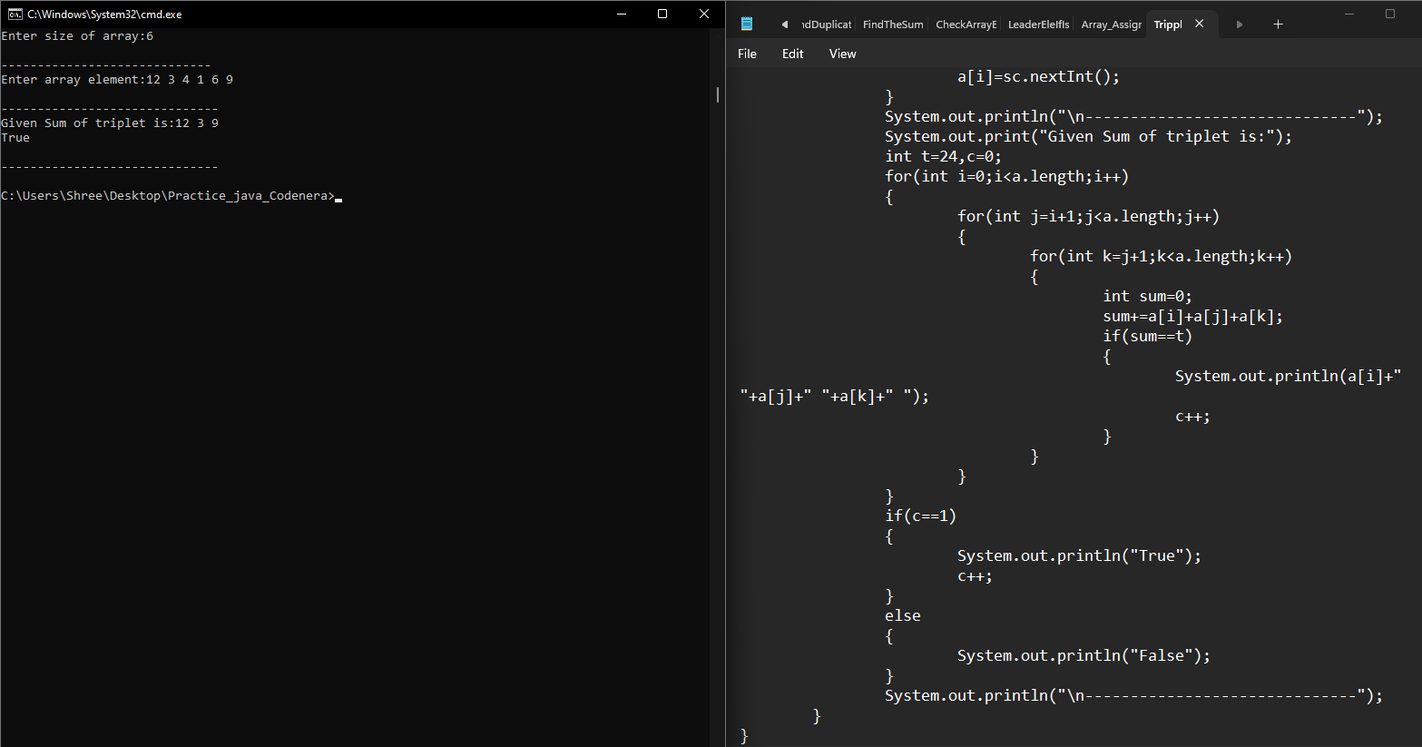

**2. Write a Java program to print all the LEADERS in the array** **Note: An element is leader if it is greater than all the elements to its right side.**

**input:a[] = {16, 17, 4, 3, 5, 2},**

**output : 17 5 2.**

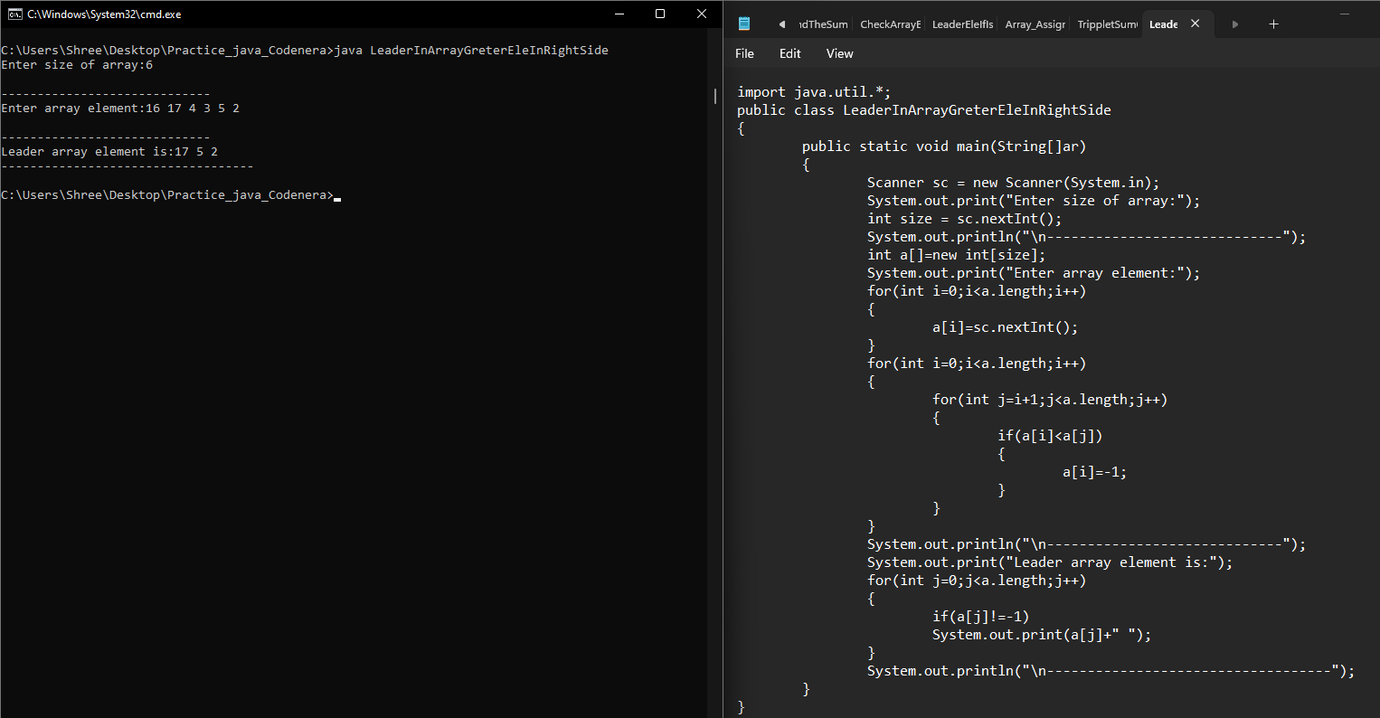

**3.** **Write a Java program to check if an array of integers contains two specified elements 65 and 77.** 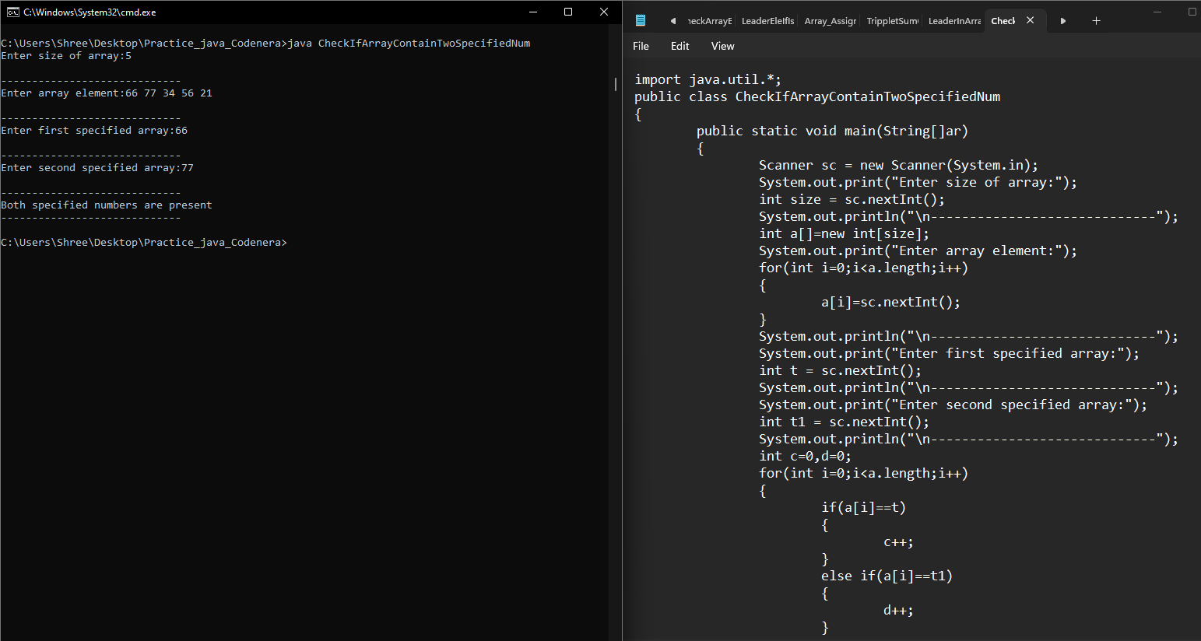

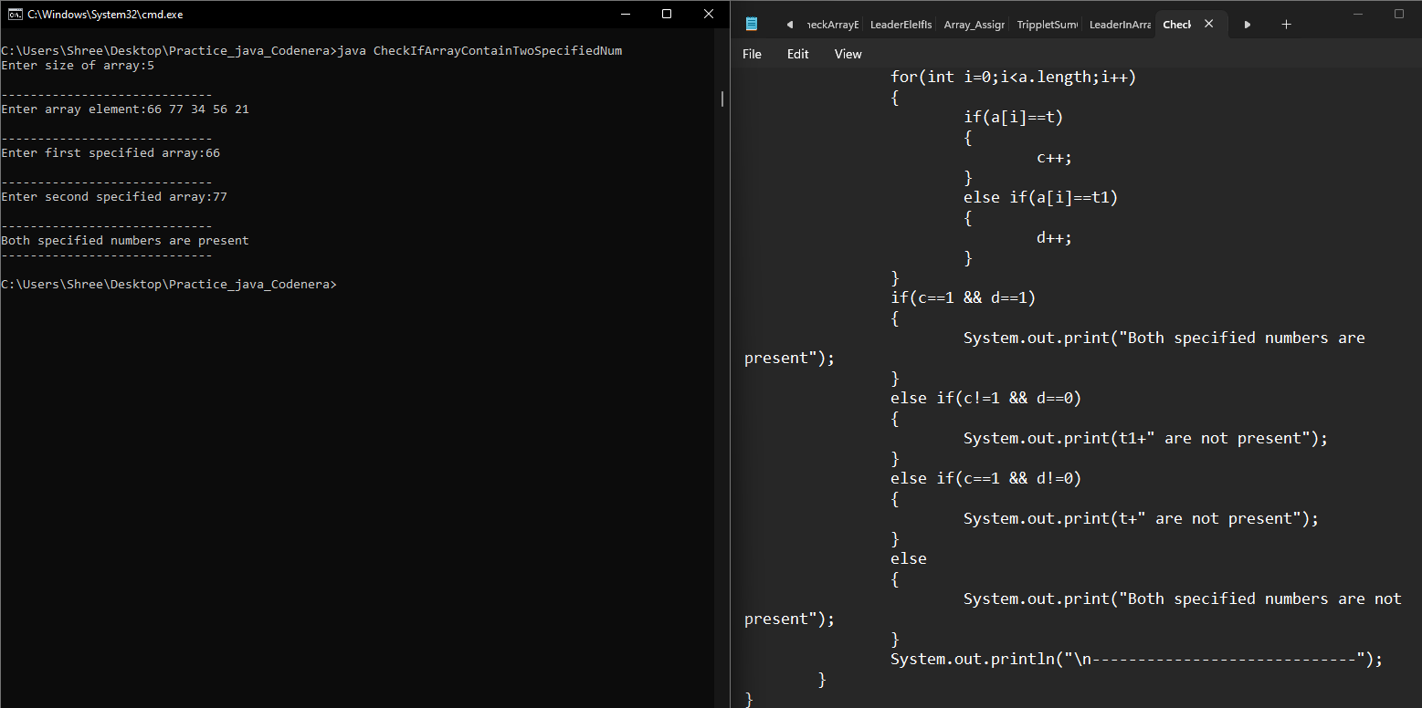

**4.** **Given an array arr[] of integers, segregate even and odd numbers in the array. Such that all the even numbers should be present first, and then the odd numbers.**

**Examples:**

**Input: arr[] = 1 9 5 3 2 6 7 11**

**Output: 2 6 5 3 1 9 7 11** 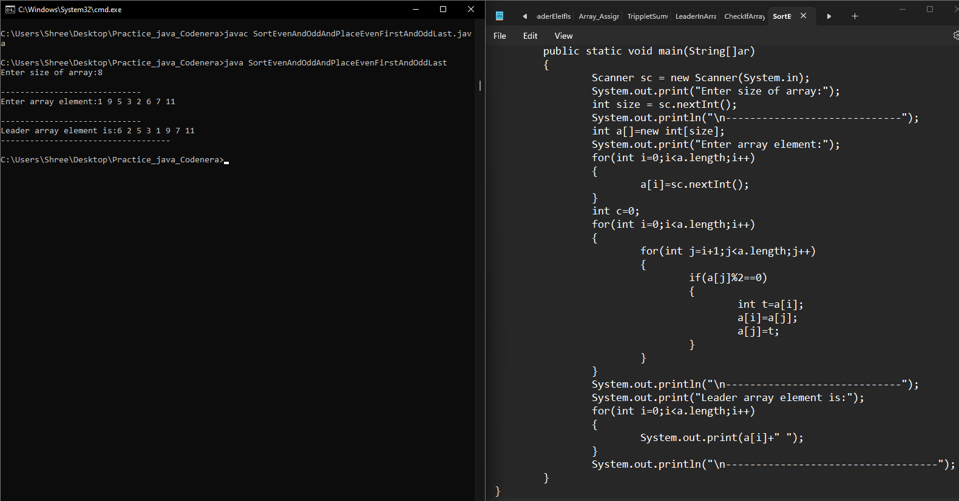

**5. Write a java program to find prime number between an array of element and shift into another array and print that prime array.**

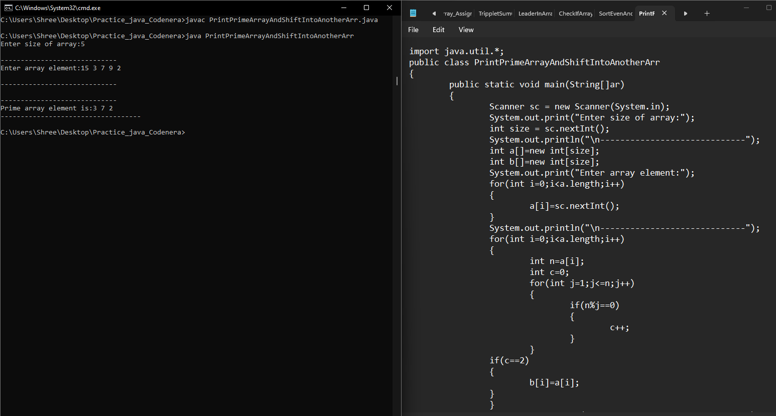

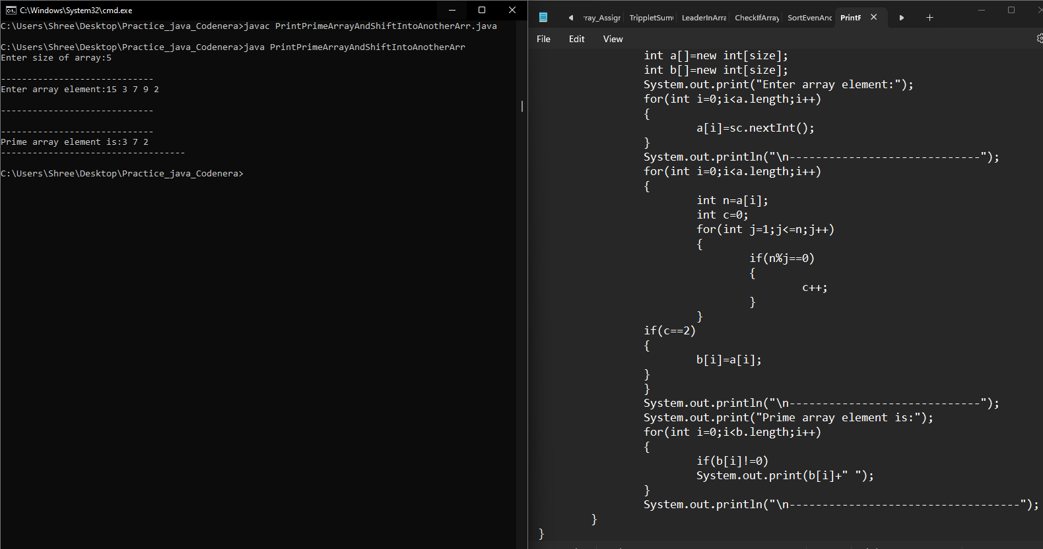

**6. Given an array of integers arr[], The task is to find the index of first repeating element in it i.e. the element that occurs more than once and whose index of the first occurrence is the smallest.** 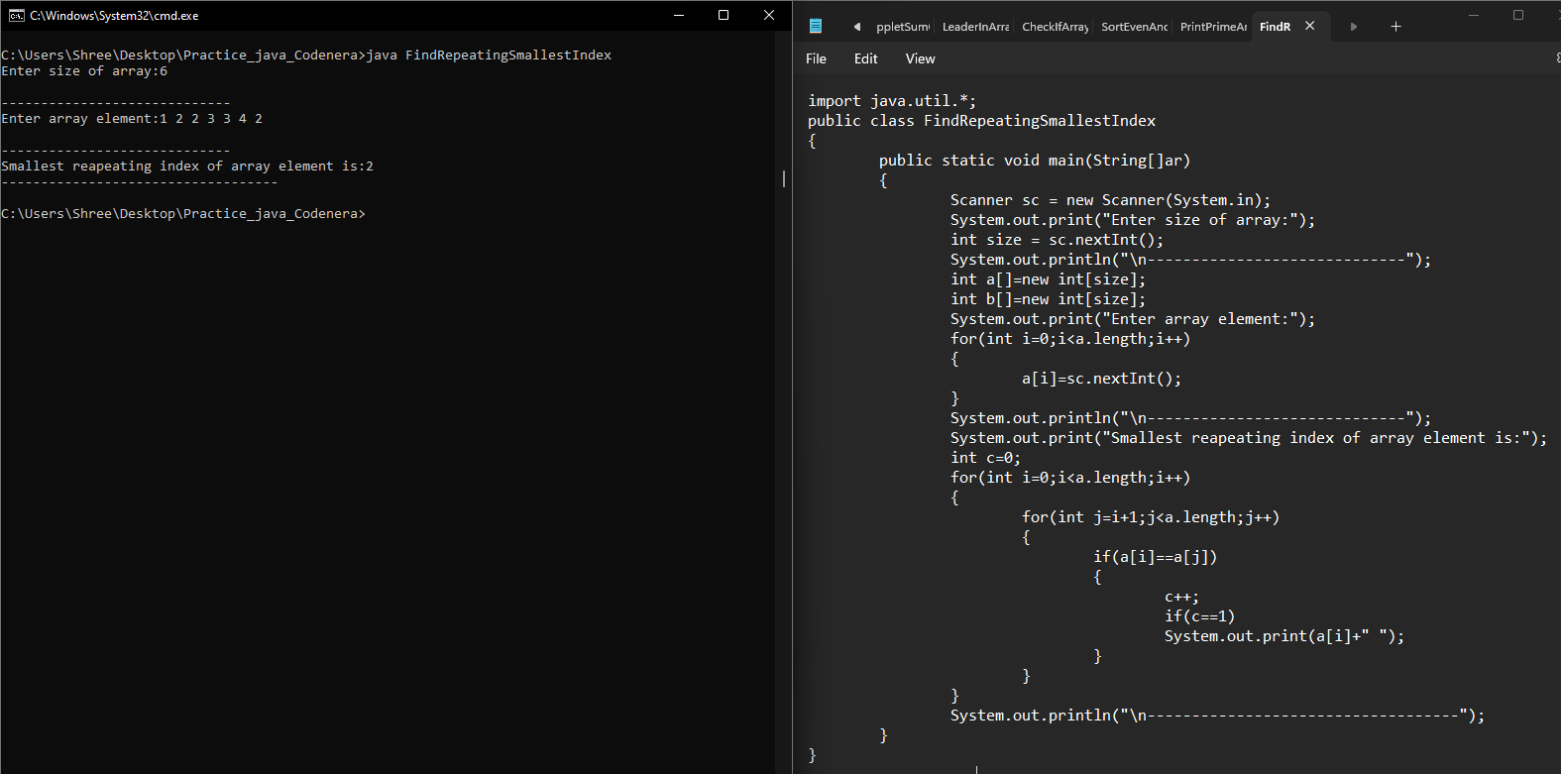

**7.** **.Given two unsorted arrays that represent two sets (elements in every array are distinct), find the union and intersection of two arrays.**

**Example:**

**arr1[] = {7, 1, 5, 2, 3, 6}**

**arr2[] = {3, 8, 6, 20, 7}**

**Then your program should print Union as {1, 2, 3, 5, 6, 7, 8, 20}**

**And Intersection as {3, 6, 7}. Note that the elements of union and intersection can be printed in any order.** 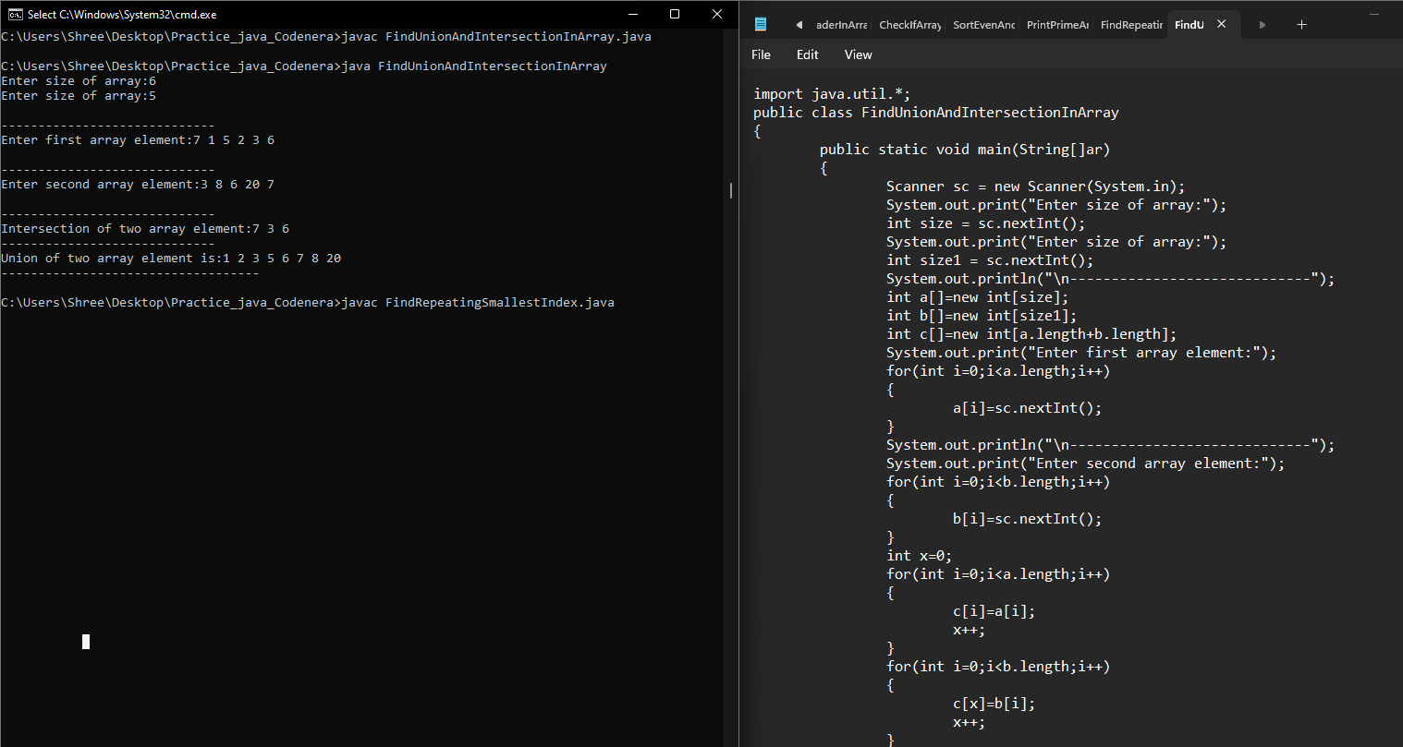

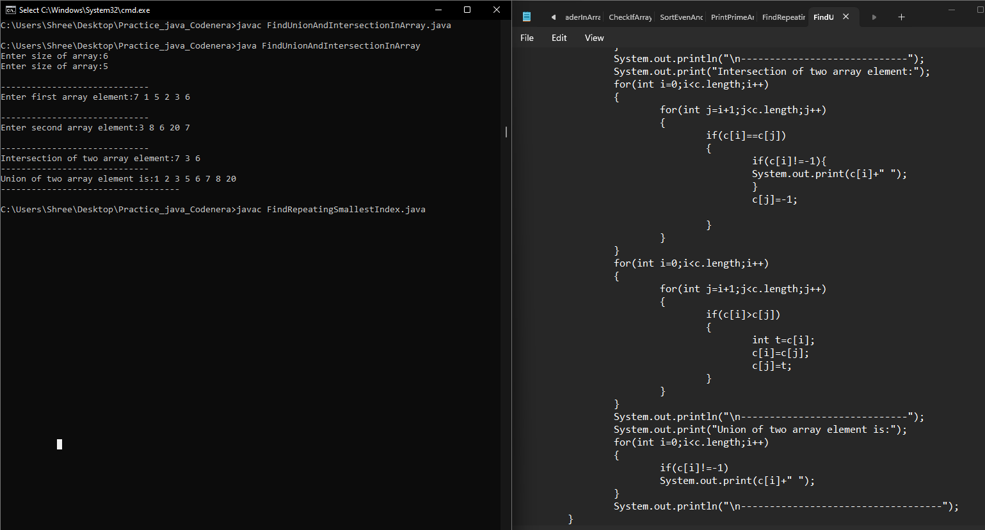

**8. Given three arrays sorted in non-decreasing order, print all common elements in these arrays.**

**Examples:**

**Input:**

**ar1[] = {1, 5, 10, 20, 40, 80}**

**ar2[] = {6, 7, 20, 80, 100}**

**ar3[] = {3, 4, 15, 20, 30, 70, 80, 120}**

**Output: 20, 80** 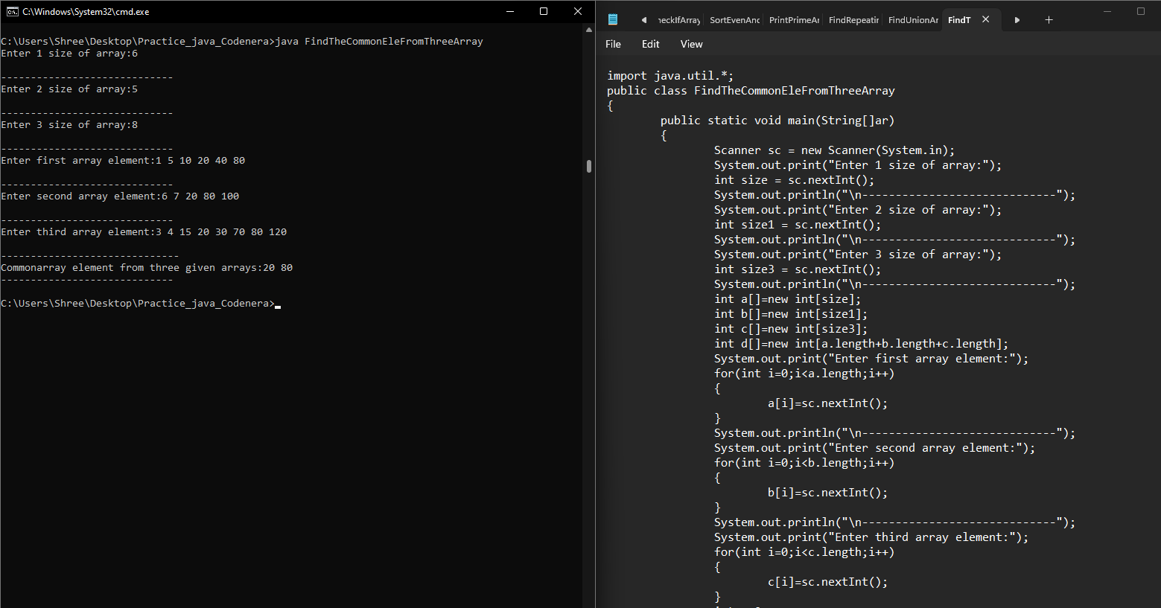

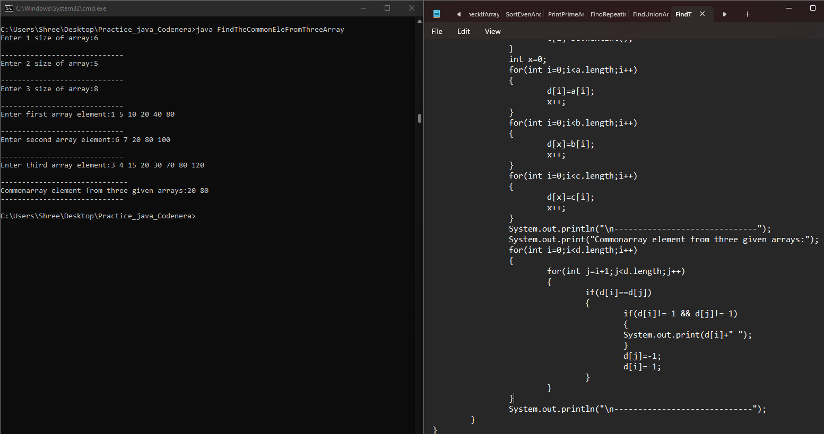

**9. Given an array of integers. All numbers occur twice except one number which occurs once. Find the number in O(n) time & constant extra space.**

**Example :**

**Input: arr[] = {2, 3, 5, 4, 5, 3, 4}**

**Output: 2** 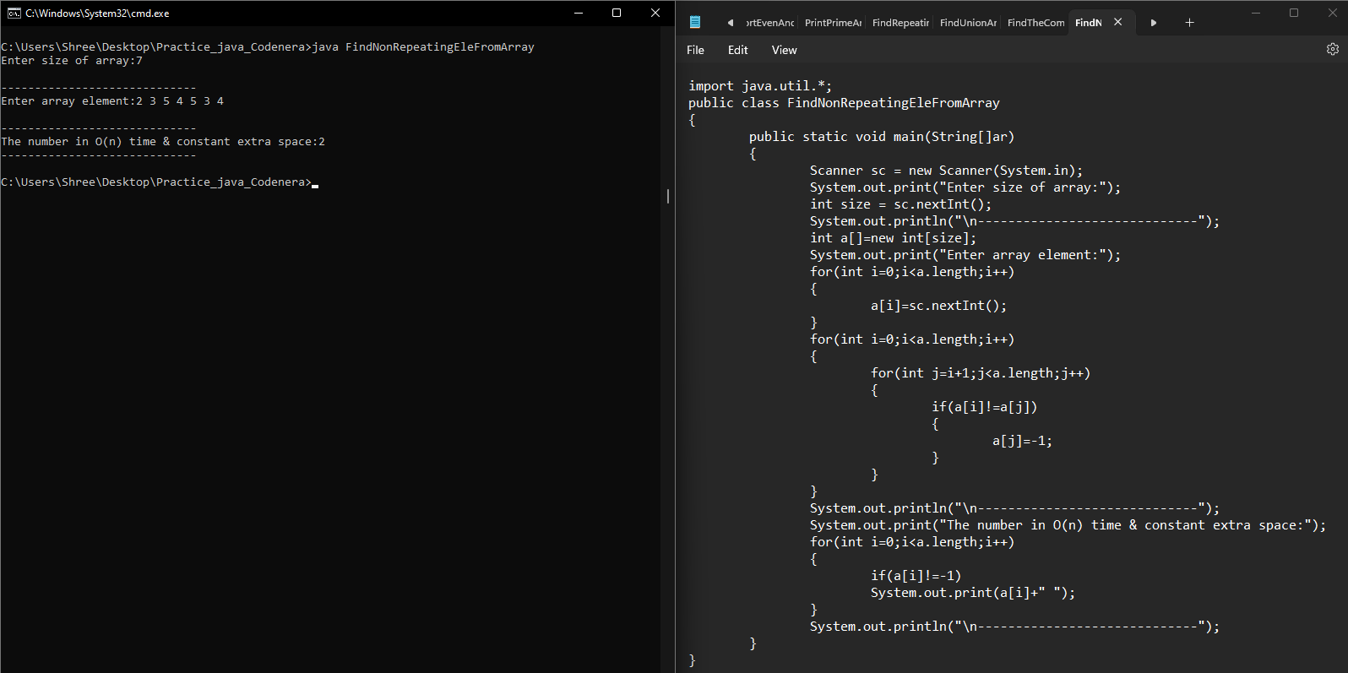

**10. Write a program input an array now insert any element at any position,**

**Element and position is taken by user.** 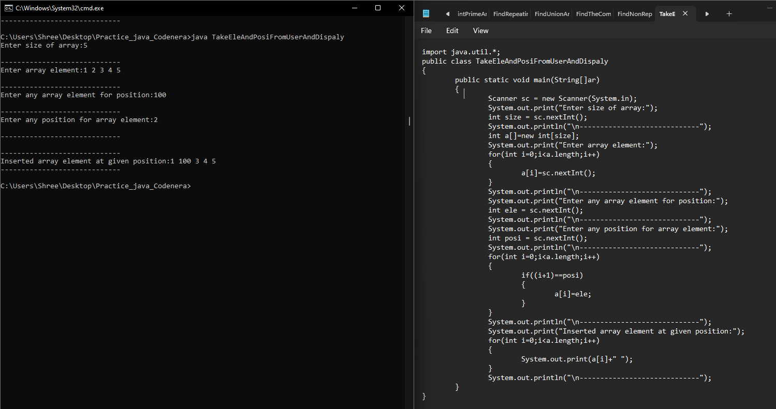

**11.** **Given a sorted array of n distinct integers where each integer is in the range from 0 to m-1 and m > n. Find the smallest number that is missing from the array.**

**Examples:**

**Input: {0, 1, 2, 6, 9}, n = 5, m = 10**

**Output: 3**

**12. Write a program input an array now delete element from array, position is taken from user.**

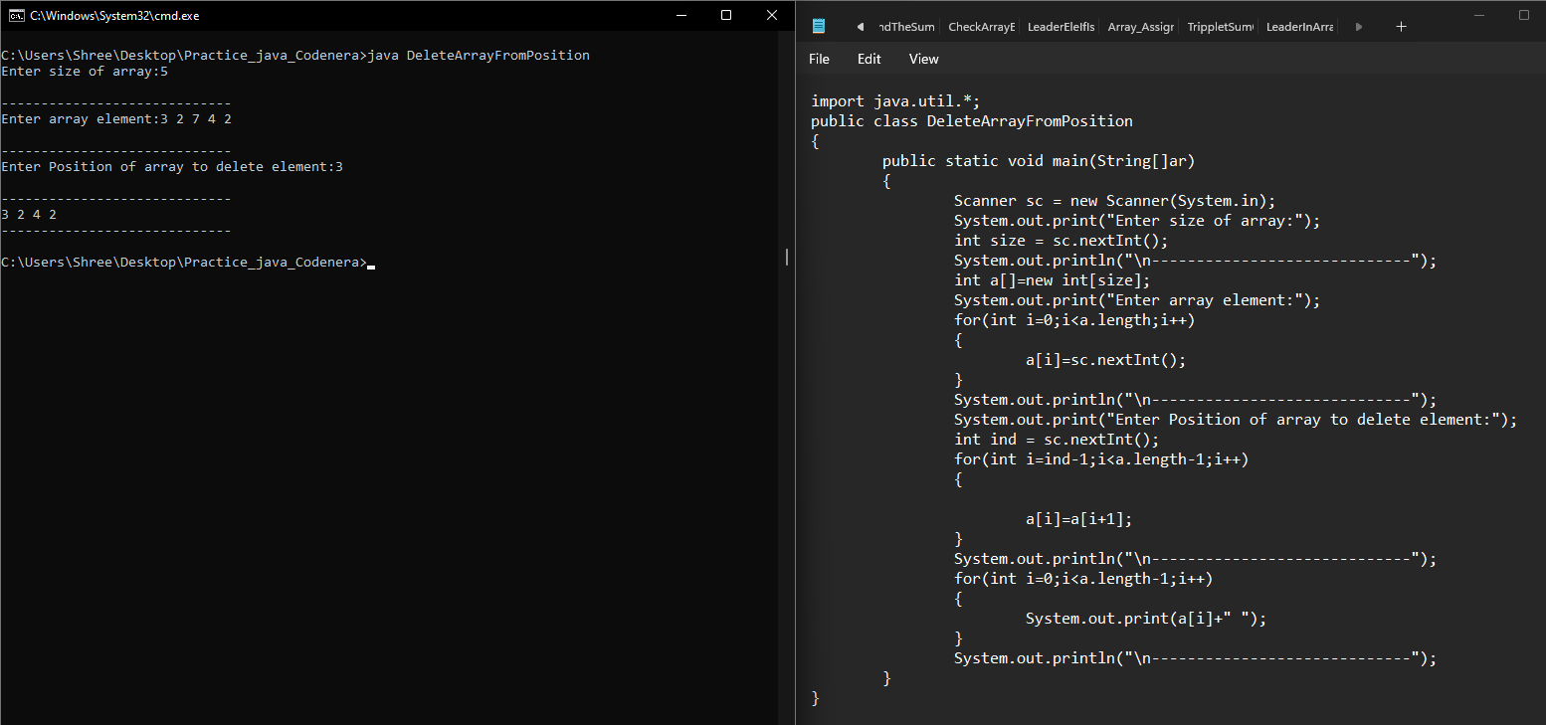

**13. Write a program enter an array and print the square of the element which is present at odd position.**

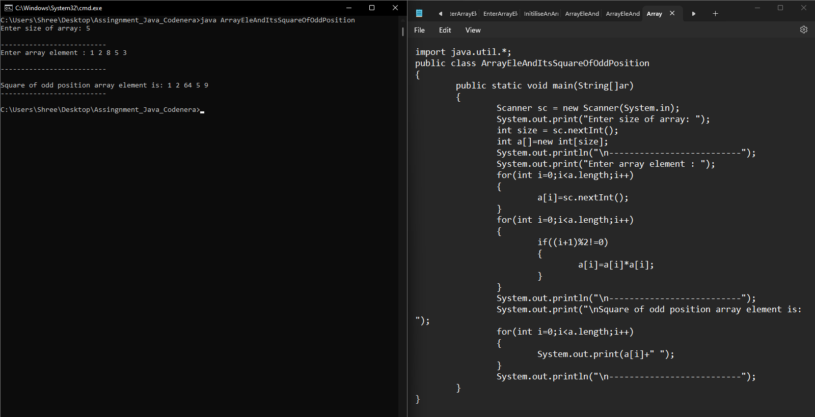

**14. Write a program input an array and rotate it in anti-clock wise by any no given by user.**

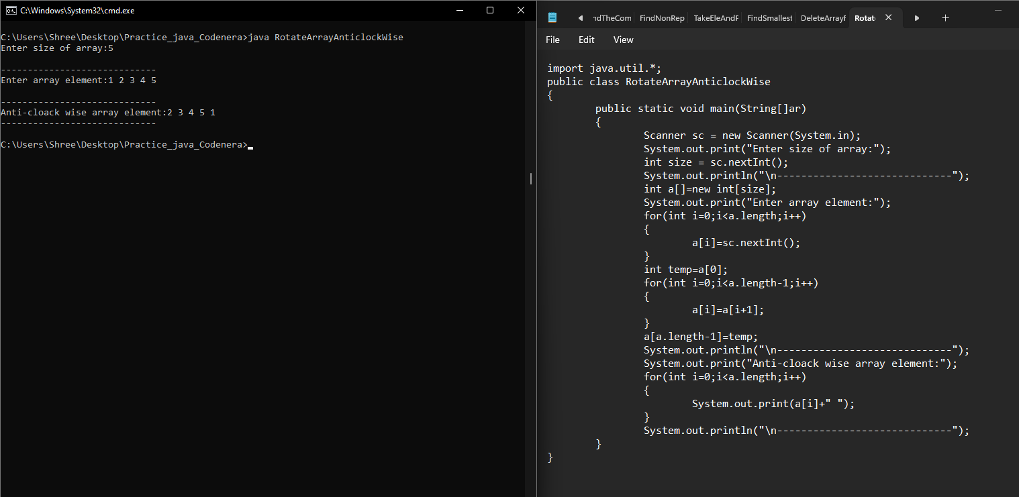

**15. Write a program input an array and rotate it in clock wise by any no given by user.** 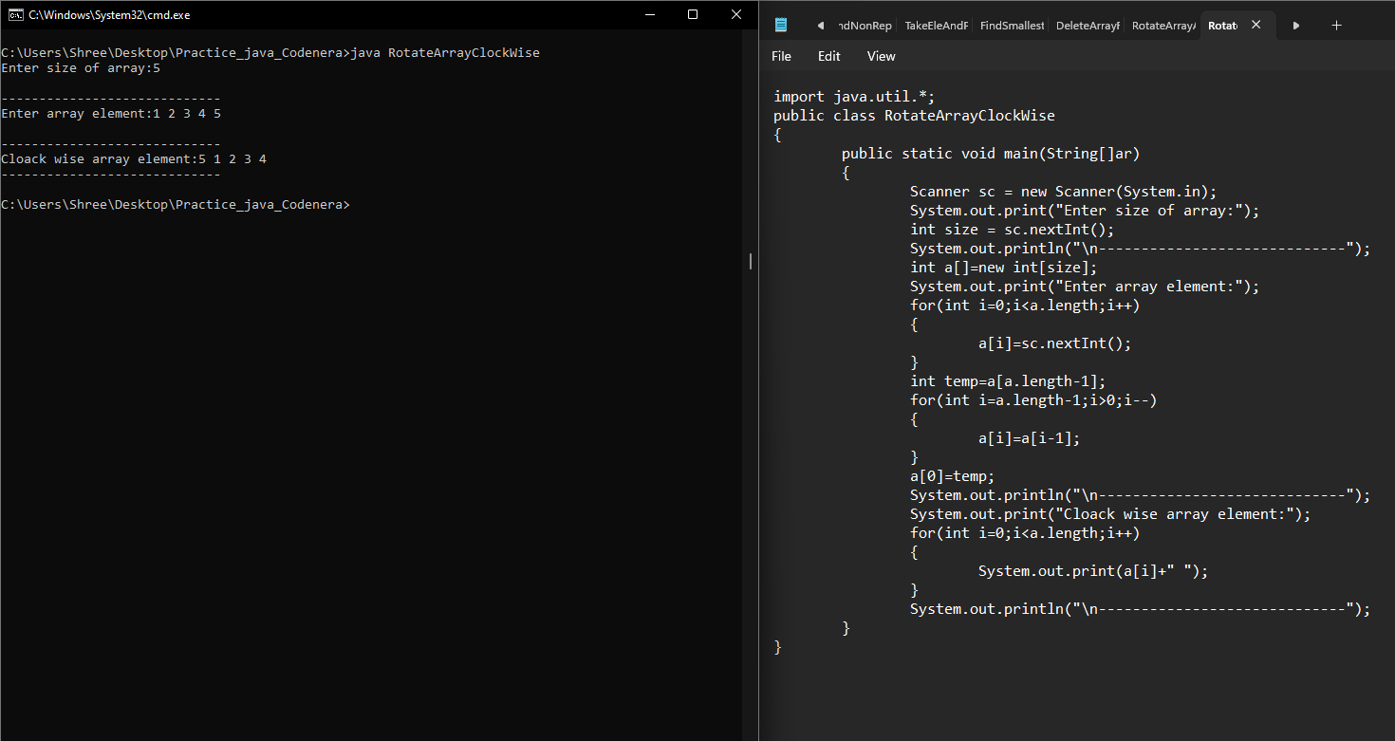

**16. Write a program input an array and delete all duplicate element from array.**

